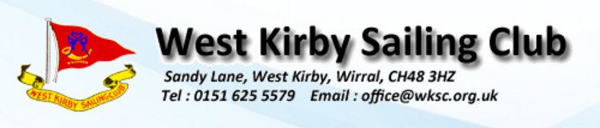

Team Name : _______________________________

Team Captain : _________________________________

**BREAKFAST ORDER**

|  |  |  |  |
| --- | --- | --- | --- |
| **Option** | **Price** | **Quantity** | **Total Price** |
| Bacon Batch | £2.50 |  |  |
| Sausage Batch | £2.50 |  |  |
| Vegetarian Sausage Batch | £2.50 |  |  |
| Sausage & Egg Batch | £3.00 |  |  |
|  |  | **Breakfast Total** |  |